Blast - IBM ASPERA - Installation

Objective
- Configure BLAST to download files larger than 1GB.

Step by Step.
- When accessing the BLAST website (Contoso's file exchange system), the system allows downloading files of up to 1 GB in size.
- Access Software Center and search for the IBM Aspera program:
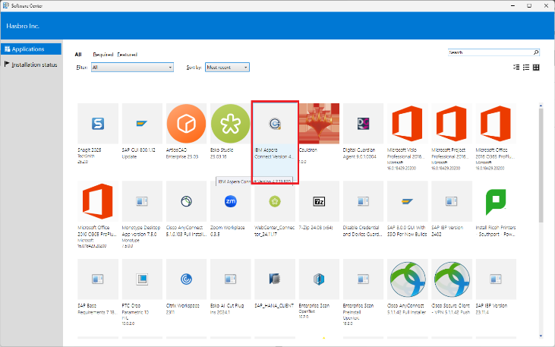
- Click the IBM Aspera program icon and then click 'Install':
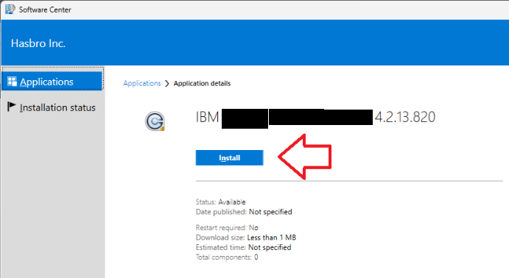
- Monitor the installation progress in the 'Installation Status' tab:
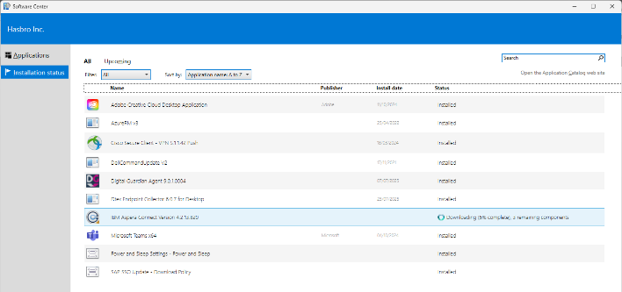
- After installation, reload the page.
- The 'ASPERA ENABLED' toggle will be available:
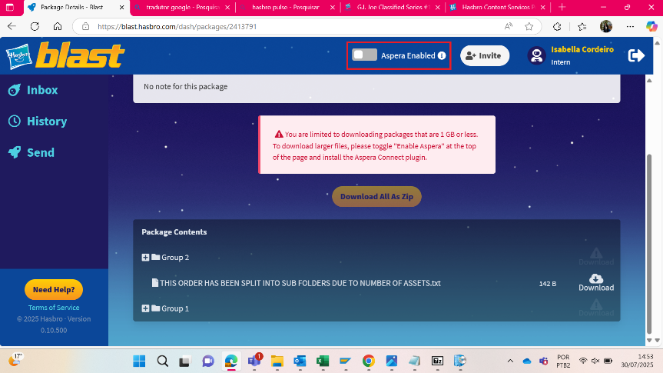
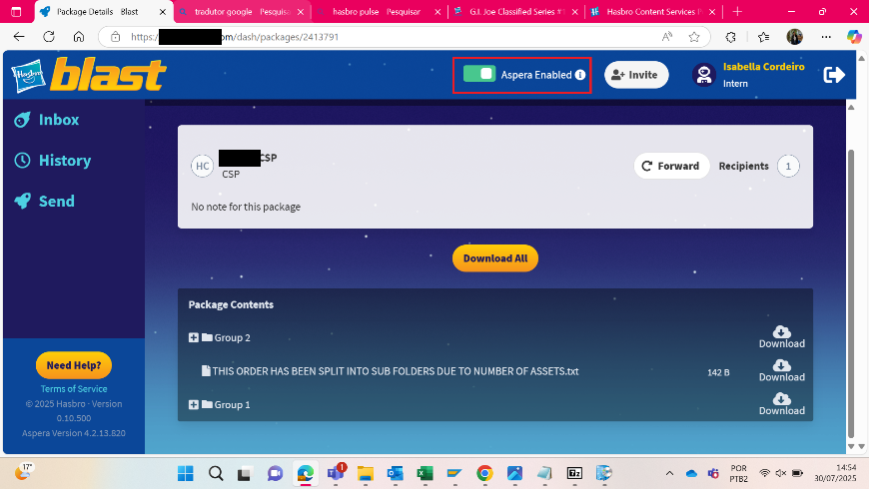
- The message about the download limit disappears and files larger than 1 GB can be downloaded.
- The user can now download files of any size.

Version History
Author | Version | Date | Description
IT Team | 1.0 | 30/07/2025 | Creation
Lucas Souza | — | Jun/2026 | Document standardization

